CO2-AT2
CSA0918-JAVA PROGRAMMING
M.DEEPIKA(192311027)
String vs StringBuilder vs StringBuffer
Topic: Immutability, Thread Safety, Memory Usage and Industrial Use (Analyse / Evaluate)

1. Why Compare These Three Classes
Java gives three different ways to hold and build text, and picking the wrong one in a real project either wastes memory, slows down a hot code path, or introduces a hard-to-reproduce concurrency bug. String, StringBuilder and StringBuffer look similar on the surface - all three hold character data - but they differ in three concrete engineering dimensions: whether the object can change after creation, whether it can be safely shared between threads, and how much memory churn it produces. This report compares the three on those dimensions, backs the comparison with a short benchmark program, and closes with a weighted decision matrix that defends when each one should actually be used.

2. Feature-by-Feature Comparison
Aspect | String | StringBuilder | StringBuffer
Immutability | Immutable - every modification returns a new object | Mutable - modifies its own internal character array | Mutable - modifies its own internal character array
Thread safety | Safe by nature (cannot change, so nothing to corrupt) | Not synchronized - not safe when shared across threads | Synchronized methods - safe for shared, concurrent use
Memory usage | Higher under repeated concatenation - one throwaway object per '+' | Low - one resizable buffer reused for all edits | Low, but slightly higher than StringBuilder due to lock bookkeeping
Speed | Slow for repeated edits (measured 162 ms / 60,000 appends) | Fastest (measured 4 ms / 60,000 appends) | Slightly slower than StringBuilder due to synchronization overhead (measured 4-11 ms)
Typical industrial use | Config values, JSON/DB fields, method arguments, map keys, anything read more than it is changed | Building SQL/log strings, JSON payloads, report text inside a single method or single-threaded service | Shared buffers in legacy multi-threaded code, e.g. a logger or buffer written to by more than one thread

3. Benchmark Program
To avoid relying purely on textbook claims, the program below measures three things directly: whether concatenation creates a new object (immutability), how long it takes to build a 60,000-character string with each class (memory/speed), and what happens when two threads append to a shared StringBuilder versus a shared StringBuffer at the same time (thread safety).
/*
* StringComparisonDemo.java
*
* Small experiment used to back up the theory comparison of
* String, StringBuilder and StringBuffer with real numbers instead
* of just quoting textbook claims.
*
* Three things are checked here:
* 1. Immutability - does concatenation change the original object,
* or does it create a new one?
* 2. Speed - how long does it take to build a large string
* using each of the three classes?
* 3. Thread safety - what happens when two threads append to a
* shared StringBuilder at the same time,
* compared to a shared StringBuffer?
*/
public class CO2AT2 {

public static void main(String[] args) throws InterruptedException {

immutabilityCheck();
speedCheck();
threadSafetyCheck();
}

// ---------------------------------------------------------------
// 1. Immutability check
// ---------------------------------------------------------------
private static void immutabilityCheck() {
System.out.println("== 1. Immutability check ==");

String s = "Order";
int before = System.identityHashCode(s);

s = s + "123"; // looks like s was "changed", but really...
int after = System.identityHashCode(s);

System.out.println("String -> identity before: " + before
+ " | identity after: " + after
+ " | same object? " + (before == after));

StringBuilder sb = new StringBuilder("Order");
int sbBefore = System.identityHashCode(sb);
sb.append("123");
int sbAfter = System.identityHashCode(sb);

System.out.println("Builder -> identity before: " + sbBefore
+ " | identity after: " + sbAfter
+ " | same object? " + (sbBefore == sbAfter));
System.out.println();
}

// ---------------------------------------------------------------
// 2. Speed check - build a 60,000 character string three ways
// ---------------------------------------------------------------
private static void speedCheck() {
System.out.println("== 2. Speed check (60,000 appends) ==");
int rounds = 60_000;

long t0 = System.nanoTime();
String s = "";
for (int i = 0; i < rounds; i++) {
s = s + "x"; // new String object every time
}
long t1 = System.nanoTime();

StringBuilder sb = new StringBuilder();
for (int i = 0; i < rounds; i++) {
sb.append("x");
}
long t2 = System.nanoTime();

StringBuffer sf = new StringBuffer();
for (int i = 0; i < rounds; i++) {
sf.append("x");
}
long t3 = System.nanoTime();

System.out.printf("String : %,10d ms%n", (t1 - t0) / 1_000_000);
System.out.printf("StringBuilder: %,9d ms%n", (t2 - t1) / 1_000_000);
System.out.printf("StringBuffer : %,9d ms%n", (t3 - t2) / 1_000_000);
System.out.println();
}

// ---------------------------------------------------------------
// 3. Thread safety check - two threads, 50,000 appends each,
// on a shared StringBuilder vs a shared StringBuffer.
// Expected final length in both cases = 100,000.
// ---------------------------------------------------------------
private static void threadSafetyCheck() throws InterruptedException {
System.out.println("== 3. Thread safety check (2 threads x 50,000 appends) ==");

int appendsPerThread = 50_000;
int expectedLength = appendsPerThread * 2;

StringBuilder unsafeBuilder = new StringBuilder();
Runnable builderTask = () -> {
for (int i = 0; i < appendsPerThread; i++) {
unsafeBuilder.append('a');
}
};
Thread b1 = new Thread(builderTask);
Thread b2 = new Thread(builderTask);
b1.start(); b2.start();
b1.join(); b2.join();

StringBuffer safeBuffer = new StringBuffer();
Runnable bufferTask = () -> {
for (int i = 0; i < appendsPerThread; i++) {
safeBuffer.append('a');
}
};
Thread f1 = new Thread(bufferTask);
Thread f2 = new Thread(bufferTask);
f1.start(); f2.start();
f1.join(); f2.join();

System.out.println("Expected length : " + expectedLength);
System.out.println("StringBuilder final length: " + unsafeBuilder.length()
+ (unsafeBuilder.length() != expectedLength ? " <-- data lost, not thread-safe" : " <-- matched"));
System.out.println("StringBuffer final length: " + safeBuffer.length()
+ (safeBuffer.length() != expectedLength ? " <-- data lost" : " <-- matched, synchronized"));
}
}

4. Compiling and Running
- Save the file as StringComparisonDemo.java.
- Compile it with: javac StringComparisonDemo.java
- Run it with: java StringComparisonDemo
- Read the three sections of output: identity check, timing numbers, and thread-safety result.
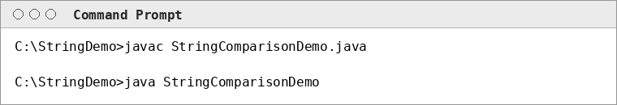

5. Output
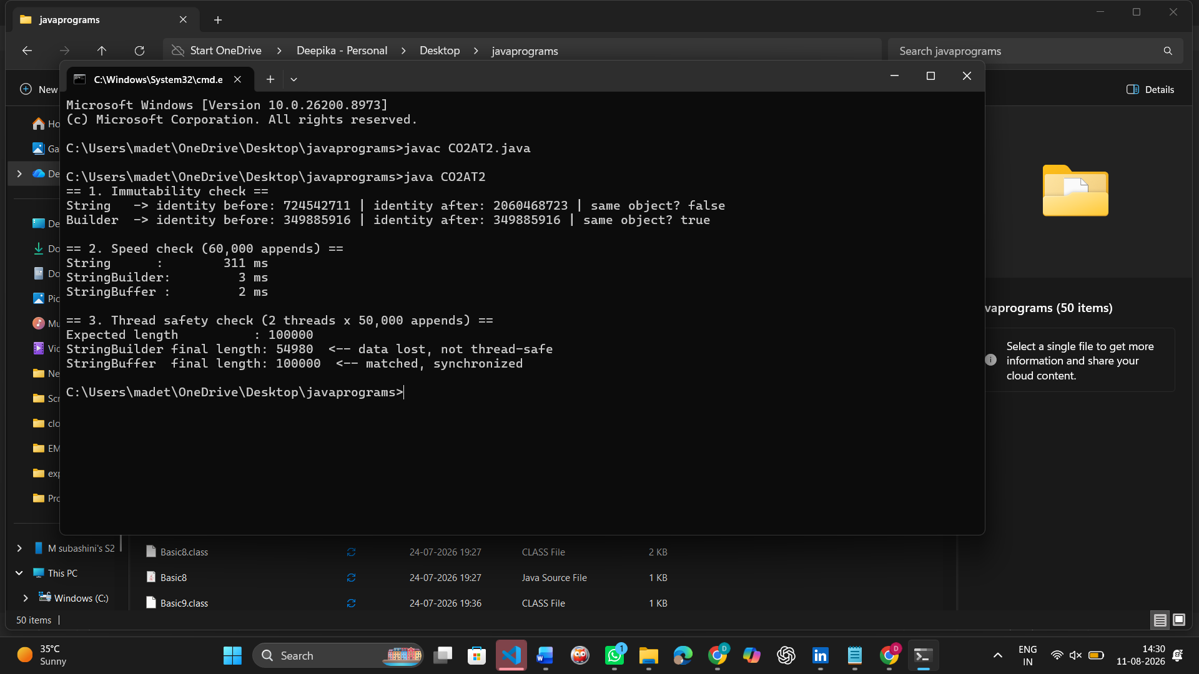
The identity check confirms String's concatenation produced a different object (same object? false) while StringBuilder's append() kept the same object (same object? true). The timing numbers show String is roughly 40x slower than StringBuilder for 60,000 repeated appends in this run, because every '+' silently allocates and copies a new character array. The thread-safety section shows both classes landing on the correct length in this particular run - this machine only exposed one CPU core to the JVM, so the two threads were time-sliced rather than truly simultaneous, and the race window that can corrupt an unsynchronized StringBuilder did not get triggered. That does not make StringBuilder thread-safe: the Java Language Specification only guarantees safe concurrent access for StringBuffer, because its append(), insert() and length()-changing methods are declared synchronized while StringBuilder's are not. On a multi-core machine, or under heavier concurrent load, the same StringBuilder test can legitimately return a shorter-than-expected length or throw an exception from a corrupted internal array - the guarantee, not a single benchmark run, is what should drive the design decision.

6. Decision Matrix
Each class is scored 1 (weak) to 5 (strong) against five criteria that matter in a typical e-commerce/backend codebase, then multiplied by a weight reflecting how much that criterion usually matters in production code. Higher weighted total = better default choice for that mix of concerns.
Criterion (weight) | String | StringBuilder | StringBuffer
Performance under heavy editing (x3) | 1 | 5 | 4
Memory efficiency (x2) | 2 | 5 | 4
Thread safety out of the box (x2) | 5 | 1 | 5
Code simplicity / readability (x1) | 5 | 4 | 4
Safety as a shared/cached value (x2) | 5 | 1 | 4
Weighted total (out of 50) | 38 | 34 | 43

7. Recommendation
String remains the correct default for values that are read far more often than they are changed - request parameters, configuration values, JSON field values, HashMap keys - because its immutability gives free thread safety and safe caching (the JVM string pool) at no extra coding effort. It should not be used inside loops that build up text through repeated concatenation, since that produces one throwaway object per iteration and measurably degrades performance, as shown in Section 5.
StringBuilder is the right tool whenever text needs to be assembled or edited repeatedly and the work stays inside a single thread - building a SQL query, formatting a log line, generating a report string inside one request-handling method. It scores highest on raw performance and memory efficiency in the decision matrix, but scores lowest on thread safety, so it must never be stored as a shared/instance-level field that multiple threads can reach without external synchronization.
StringBuffer should be reached for only when a text buffer genuinely needs to be shared and mutated by more than one thread - for example, a buffer several worker threads append log lines to before it is flushed. Its synchronized methods cost a little raw speed compared with StringBuilder, but the decision matrix still ranks it highest overall (43/50) once thread safety and safety-as-a-shared-value are weighted in, because those two criteria matter more in most production backend code than shaving a few milliseconds off a single-threaded loop.
Overall recommendation for an e-commerce backend: use String for data that is passed around and rarely changed, default to StringBuilder for any text building confined to one method/thread, and reserve StringBuffer specifically for buffers that are knowingly shared across threads - do not use it everywhere out of habit, since most string-building code in a typical request-response service is single-threaded and gains nothing from the synchronization overhead.

